Bexley Wrestling Important Dates

- Open mats start Monday, April 1st, 2019 @ 6 pm and will continue every Monday
- Tournament Of Champions, April 27th, 2019, https://ohiotofc.com/
- Mulch Sale, 8 am to 12 pm, April 27th, 2019 (same day as prom)
- New Albany Duals, May 11th, 2019, contact Coach Bragg 614-915-6007/chris.bragg@bexleyschools.org
- Bexley Wrestling Camp, M-F, June 3rd-7th, 10th-14th 430 pm-630 pm, Bexley Summer Open on June 15th
- 2019-2020 season starts November 15th (see calendar on www.bexley wrestling.com for practice/meet dates and please plan vacation around them)

Open Mats and Weight Lifting

- Weight Lifting @ Bexley Weight Room everyday after school. You can lift with football, another sport or on your own with the strength coach, but you need to be in the weight room!

- Go to as many open mats as possible. Generally, once a week for an hour or so works best!

- There will be Spring, Summer and Fall Competition Nights throughout Central Ohio. These will be announced on our twitter handle and fb page.

Camps

We suggest at least one camp a year. There are three camps listed below which are fairly well known in Ohio. Each one of these camps has multiple sessions to attend so if one week or weekend does not work out, there is usually other sessions you can make work. Feel free to look at others as most colleges with wrestling programs hold a few every year.

- Jeff Jordan’s State Champ Spring Weekend Camps
http://www.jordantrained.com/index.php
- Ohio State Wrestling Camps
http://www.ohiostatebuckeyes.com/camps/m-wrestl-camp2.html
- Randy’s Attack System
http://www.randyswrestlingsite.com/index.html
- JROB Wrestling Camps
https://jrobinsoncamps.com/

Open Tournaments

We suggest you go to as many as possible, at least one a month. These are the main sites which show the open tournaments in the off season in Ohio. If you plan to go to another state for a few weeks and would like to participate, there are open tournaments in most every state. Ask one of the coaches to help you find one if you are having trouble.
http://ohiotournaments.com/
http://www.ohiowrestler.com/OW_14_Youth_Tourney.htm
https://register.ohioathletics.com/tournaments

Important Wrestling Websites

OHSAA Wrestling
https://ohsaa.org/sports/wrestling

Ohio Chatter
http://www.ohiochatter.com/forum/forumdisplay.php?10-Wrestling
Ohio Tournaments
http://ohiotournaments.com/

Ohio Wrestler
http://www.ohiowrestler.com/OW_14_Youth_Tourney.htm

Ohio Athletic Committee
https://register.ohioathletics.com/tournaments

Baumspage
http://www.baumspage.com/wr/

JJHUDDLE
http://www.jjhuddle.com/wrestling

Yappi
http://www.yappi.com/forums/forumdisplay.php?f=19

Jake's Wrestling
http://www.jakeswrestling.com/default.htm

TOURNAMENT NAME | LOCATION | DATE | Organization | AGE RANGE | ENTRY FORM
The Fairland Dragon Open | Fairland, Ohio | Saturday, March 2nd | NONE | 4-18 | Download
The Canfield Spring Open | Canfield, Ohio | Sunday, March 3rd | OHIOQUEST | Open, Rookie, MS, HS & Masters | Download
The Wooster Spring Open | Wooster, Ohio | Sunday, March 3rd | OHIOQUEST | Open, Rookie, MS, HS & Masters | Download
The Bay Village Battle for the Belt | Bay Village, Ohio | Sunday, March 3rd | OHIOQUEST | Open, Rookie, MS, HS & Masters | Download
The Ontario Warrior Battle for the Belt | Ontario, Ohio | Sunday, March 10th | OHIOQUEST | Open, Rookie, MS, HS & Masters | Download
The Westerville Central Spring Open | Westerville, Ohio | Sunday, March 10th | OHIOQUEST | Open, Rookie, MS, HS & Masters | Download
The Rootstown Rover Rumble Spring Open | Rootstown, Ohio | Sunday, March 10th | OHIOQUEST | Open, Rookie, MS, HS & Masters | Download
The Triway Spring Open | Wooster, Ohio | Saturday, March 16th | OHIOQUEST | Open, Rookie, MS, HS & Masters | Download
The Liberty Center Spring Open | Liberty Center, Ohio | Saturday, March 16th | NONE | 5-18 | Download
The Cory Washburn Memorial Tournament | Upper Sandusky, OH | Saturday, March 16th | NONE | 5-16 | Download
The Monroeville Spring Open | Monroeville, OH | Saturday, March 16th | None | All Ages | Download
The 30th Annual Boardman Open | Boardman, Ohio | Sunday, March 17th | OHIOQUEST | Open, Rookie, MS, HS & Masters | Download
The Wayne Trace Wrestling Tournament | Haviland, Ohio | Saturday, March 23rd | None | 5-18 | Download
The Dodge Spring Open | Columbus, Ohio | Saturday, March 30th | OHIOQUEST | Open, Rookie, MS, HS & Masters | Download
The Ellwood City Spring Open | Ellwood City, PA | Saturday, March 30th | OHIOQUEST | Open, Rookie, MS, HS & Masters | Download
The 11th Annual Archer Open | Antwerp, Ohio | Saturday, March 30th | NONE | All Ages | Download
The Canton Spring Open | Canton, Ohio | Sunday, March 31st | OHIOQUEST | Open, Rookie, MS, HS & Masters | Download
Tinora Spring Open | Defiance, Ohio | Saturday, April 6th | NONE | All Ages | Download
The Medina Buckeye Spring Open | Medina, Ohio | Sunday, April 7th | OHIOQUEST | Open, Rookie, MS, HS & Masters | Download
The Logan Elm Open | Circleville, Ohio | Saturday, April 13th | OHIOQUEST | ALL AGES | Download

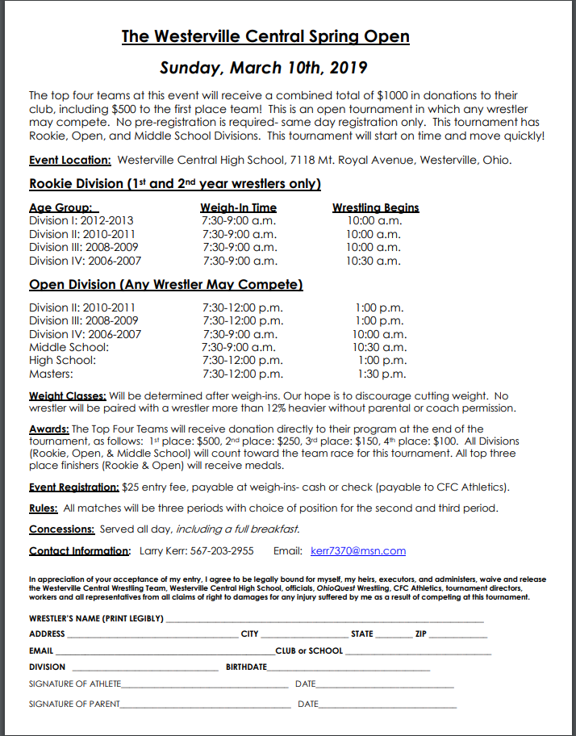
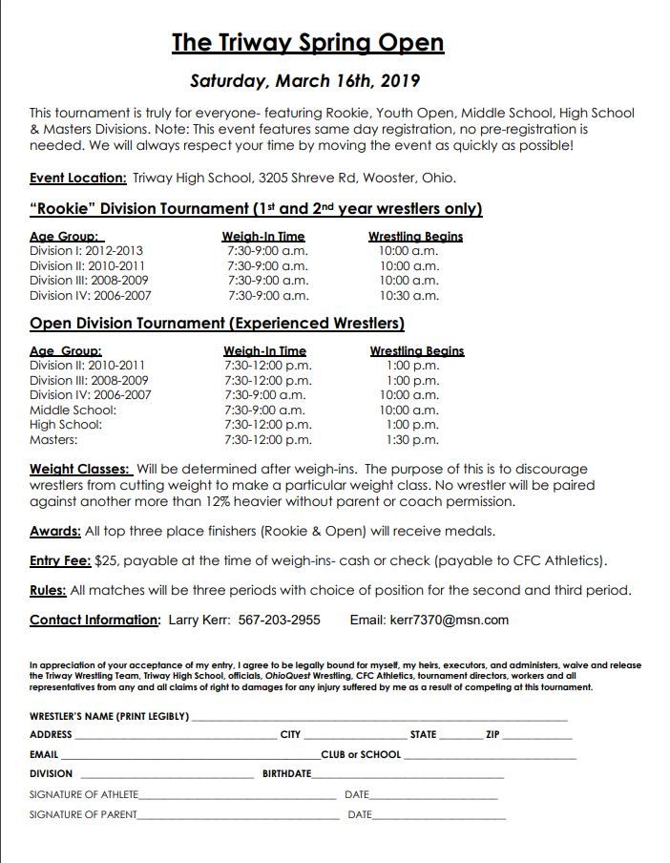
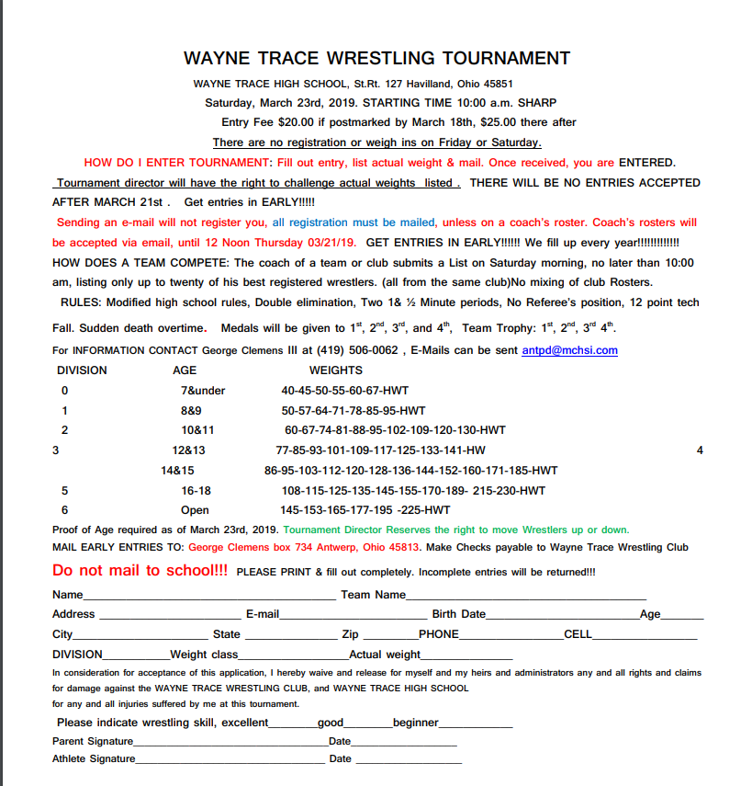
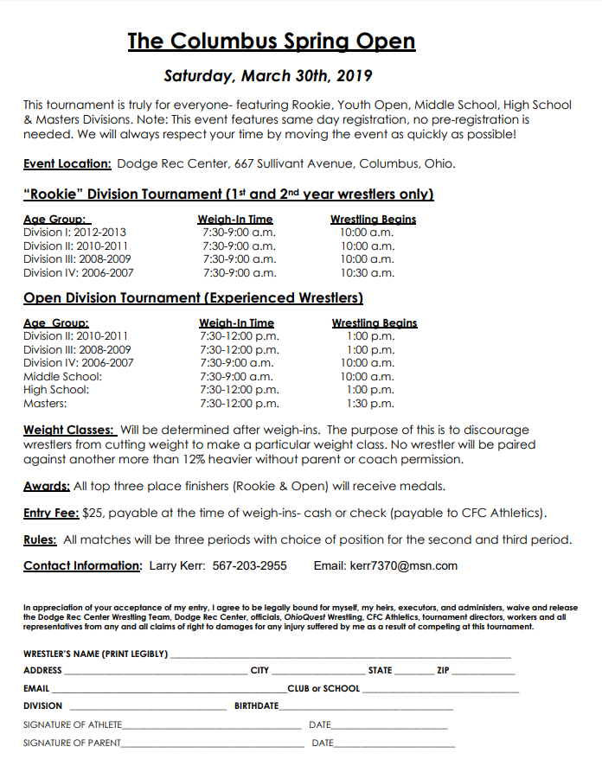
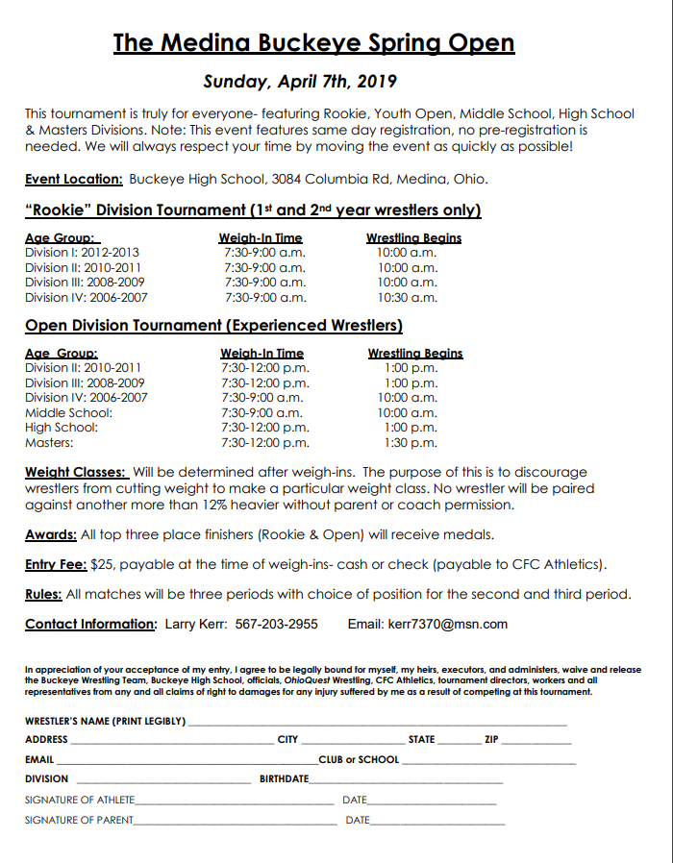
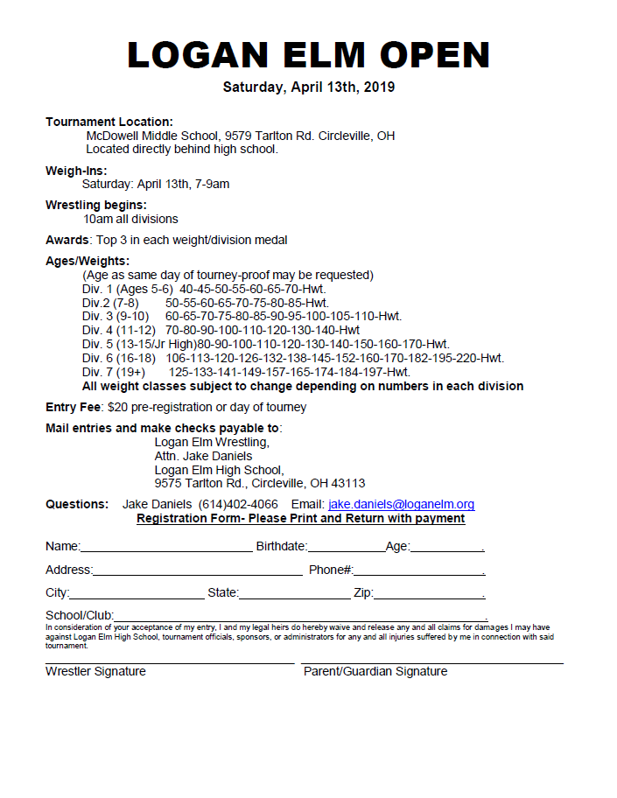
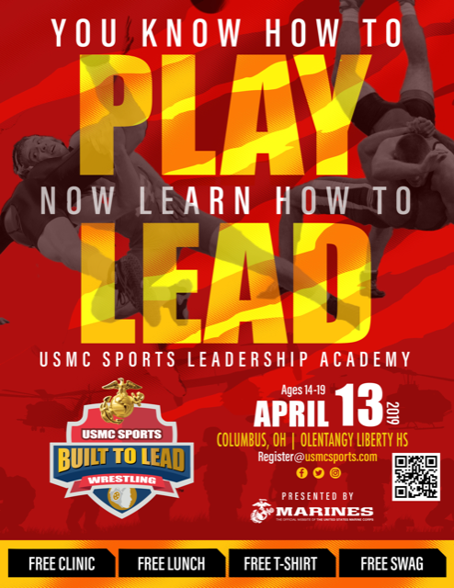
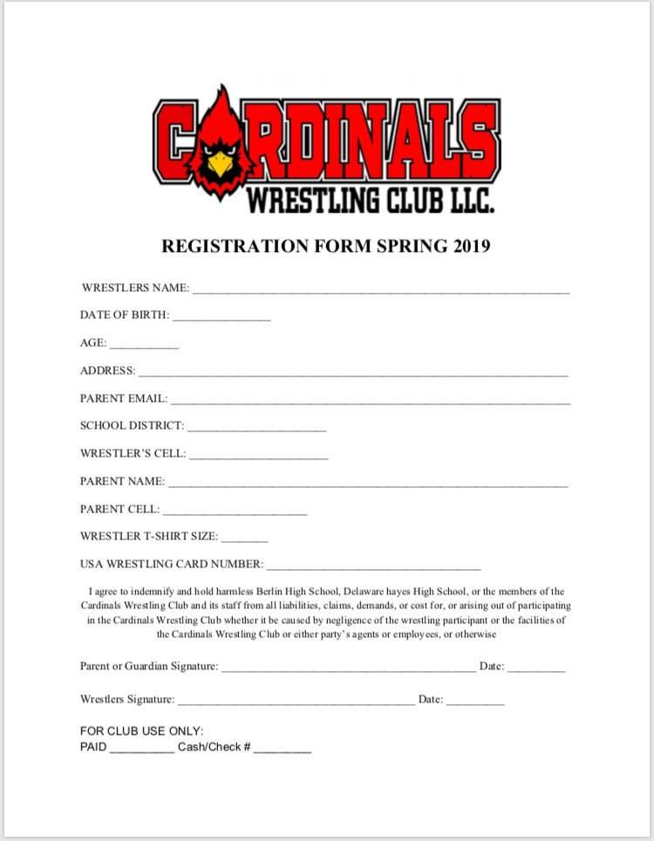
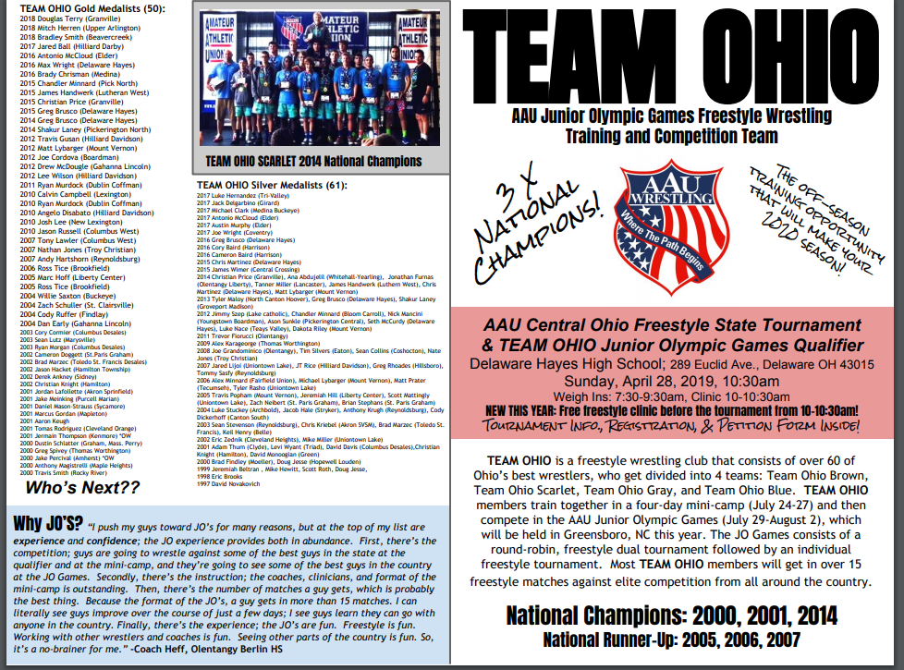
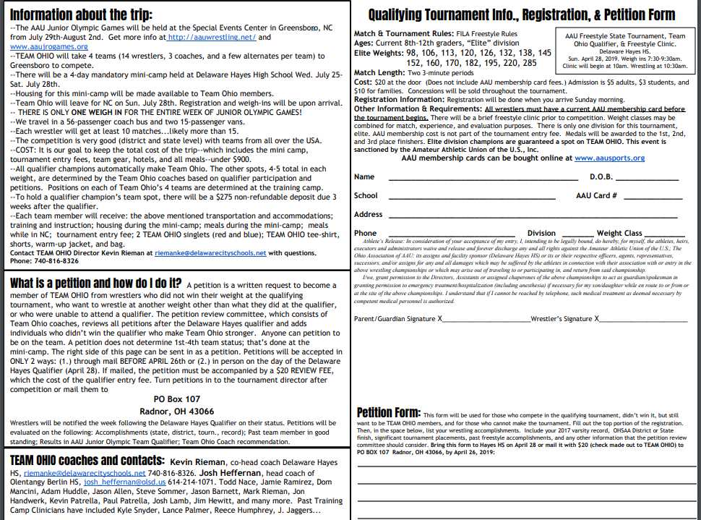
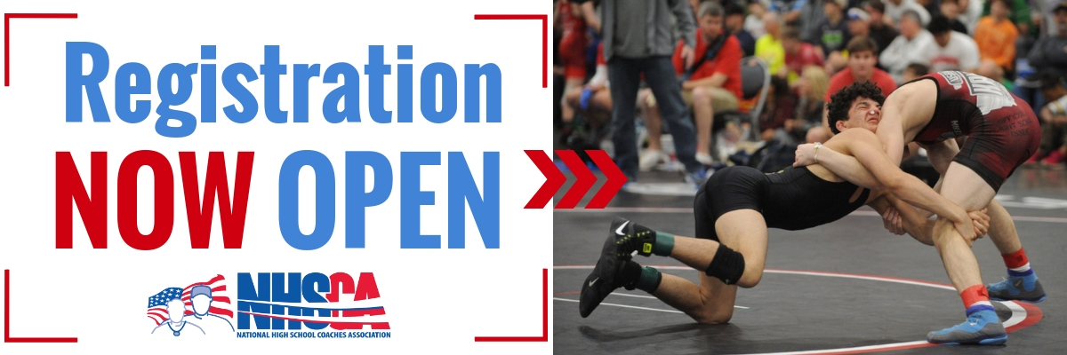
Registration for the 30th Annual
High School Nationals Has Officially Opened!
Register Early to Save on Your Entry Fee!

Date: March 29-31, 2019
Location: Virginia Beach Convention Center
Entry Fee: $55 Before March 1st | $60 After March 1st
Weigh-Ins: March 28th, 2019 | Early Weigh-Ins 2-4pm | Regular Weigh-Ins 6-8pm

Last year, the 29th Annual High School Nationals was the largest wresting tournament in the country featuring 4,430 Athletes, 960 State Champions, and 1,955 State Place Winners. Over 75% of the 2018 NCAA All-Americans competed at High School Nationals.

This year we are excited to host the Inaugural Girls Division at High School Nationals. Girls in grades 9-12 from around the country will compete to be All-Americans and National Champions.

This is an open event! There are no qualifications for you to compete.

How To Register:
- Follow the Registration Link Below
- Select Your Division (Freshman, Sophomore, Junior, Senior, Middle School, or Girls)
- Read Through the Event Info
- Click on Your Division Registration Link located at the top of the event page.
*IMPORTANT: In order to weigh-in early, March 28nd between 2-4pm, you must purchase the “Early Weigh-In” on the last page of the registration process.

REGISTER HERE
We are excited to have you compete at the “NCAA’s of High School Wrestling”. The NHSCA takes great pride in running a first-class event.
For further information or event questions:
Email: ChampionshipEvents@NHSCA.com | Phone: (610) 923-0900 | Website: www.NHSCA.com

